A Mini Project On
SOCIAL NETWORKING WEBSITE
Department of Information Technology
Submitted By
Batch:12,16

G.V.LAKSHMI 17121A1237
K.CHANDANA 17121A1248


SREE VIDYANIKETHAN ENGINEERING COLLEGE
(AUTONOMOUS)
(Affiliated to JNTUA, Ananthapuramu, Approved by AICTE, Accredited by NBA & NAAC)
Sree Sainath Nagar, Tirupati – 517 102, A.P., INDIA
2019 -2020

TABLE OF CONTENT

S. No. TITLE Pg.No.

Abstract
1. Introduction 1
2. Modules 2-3
3. Hardware and Software Requirements 4
5. Implementation 5
4. Result 6-10
5. Conclusion 11
References

ABSTRACT
Social Networking describes the phenomena found in, participatory and self- expressive Websites—such as YouTube, MySpace, Facebook— where members/participants expose, discuss, reveal, and expound on their personal lives, activities, hopes, dreams, and even fantasies for others to see and marvel upon.
Like any marketing activity, there needs to be a reason to devote time and resources. It can help you build awareness for your brand, track your competitors and/or interact with your customers. Social media can also be used to develop strategic relationships and even connect with prospects and customers.
Companies are increasingly using online communities to create value for the firm and their customers . Ensuring that brand activity is relevant to a social network’s core audience is crucial for advertisers wanting to tap into niche communities
Online communities represent a growing class of marketplace communities where participants can provide and exchange information on products, services, or common interests. Brands are, or have been, the commercial enterprises’ approach to building social networks They have created brand cohorts through logos, colours, and clever icons
One direct outcome of the social interact ion and communication among community members is the development of a common language, the establishment of community structure and status relationships, and the development of commitment to members of the community .

INTRODUCTION
Social media is a web‐based technology to facilitate social interaction between a large group of people through some type of network. In common widely used network is the Internet. But social media platforms are also for local networks as well.
Social media is growing rapidly and becoming a vital part of everyday life, because of the latest technological revolution. This stunning growth is due to the increasing usage of smart phones like BlackBerrys, Androids and iPhones. These Smart phones make it easy to access any social media platform from anywhere virtually.
The mobile versions of these social media sites are so easy to access made it user friendly. As well as the Map services made a remarkable usage through mobile to find direction and places easily.
The strengths of social media are around 112.3 million blogs,100 million of videos viewed daily and 60 million active social network site users.
With new social networking sites being introduced every year, deciding which one is right for your business, professional use or personal use is an overwhelming affair. So it becomes imperative that you have to be aware which social media sites will fit into your requirements and communication strategy. Using too many social networking sites to convey your message could dilute the entire social media strategy and your entire planning and effort will be ineffective. The best strategy is to focus on those social media sites, which are relevant to you so that you can share your content with appropriate audience.

PROJECT DETAILS
Modules
In total there are three modules. They are:-
- Sign up.
- Login.
- Add posts and comments.
2.1. Signup Module
The main objective for Sign up module is to take the user details and store them into database safely.
This module was built to take the input from the users. That is their details like the user First name, Last name, unique User name, Date of Birth, Gender, Mobile Number, registered Gmail and a strong password is recommended to stay their details safe.
2.2. Login Module
The main objective for the Login module is to extract the user details for them from database like posts, comments and photos. Login module helps to check the user with the help of password. So the details of the one user is shown correctly to that user.
The login module helps in site verification with the user gmail and password that were used in the signup time. After the website checks the details with the database with a successful verification the user is allowed to access their account.
2.3. Add Posts and Comments Module
The main objective for the add posts and comments module is to letting the user add the posts and share their comments with his community easily. They can share their happiness, talents and information that he/she has to the world.
Audience engagement can play a large role in keeping visitors on your site for longer periods of time, inviting them to explore related posts or converting them into loyal fans
On the other hand, there are people who want to create communication through account on your site can just leave a comment. When this is the case, engagement is limited and it can stifle your community growth, as this group of users might not return to your site again.
Adding social commenting with social website opens the door for more interactions by making it extra convenient for visitors to comment on your posts using their existing social media accounts. And streamlining this process might encourage previously reluctant visitors to share their thoughts.

Hardware and Software Requirements
Minimum Software Requirements
-> Browser is required to run the application.
-> Any operating system
-> Xampp server with Apache server and Mysql database in PhpMyAdmin.
-> Any Text Editor(notepad++/sublime Text).
Minimum Hardware Requirement
->4GB RAM and 1TB Hard disk is more than enough to execute and run this application
->32-bit or 64-bit processor is needed to fetch, decode and execute the instructions.

IMPLEMENTATION
Database Connection
Install the Xampp / Wamp(or any server). Start the server go to PhpMyAdmin create a database as ‘biobook’ and create four tables user,comments,photos,post. Then create coloums in user table as user_id(AUTO INCREMENT), firstname, lastname, username, username2, birthday, gender, number, email, email2, password, password2, profile_picture, cover_picture. The table post contains coloums as post_id(AUTO INCREMENT), user_id, post_image, content, created. The table photos contains coloums as photos_id(AUTO INCREMENT), location, user_id, date_added. The comments table have coloums like comment_id(AUTO INCREMENT), post_id, user_id, name, content_comment, image, created.
Signup
This module is built with html5 and css. On click of submit button the user record is registered into database using php scripts then username and password is send to their respective Email.
Login
This module is built with html5 and css. With two input text fields email and password and two buttons as login and cancel. On click of login the details are verified in database.
Add post and comments
This module is built with html5 and css. With the recent posts and comments the user at the top. The posts and comments are send to database with user id by writing php scripts.

RESULT

Fig. 4.1 Home Page



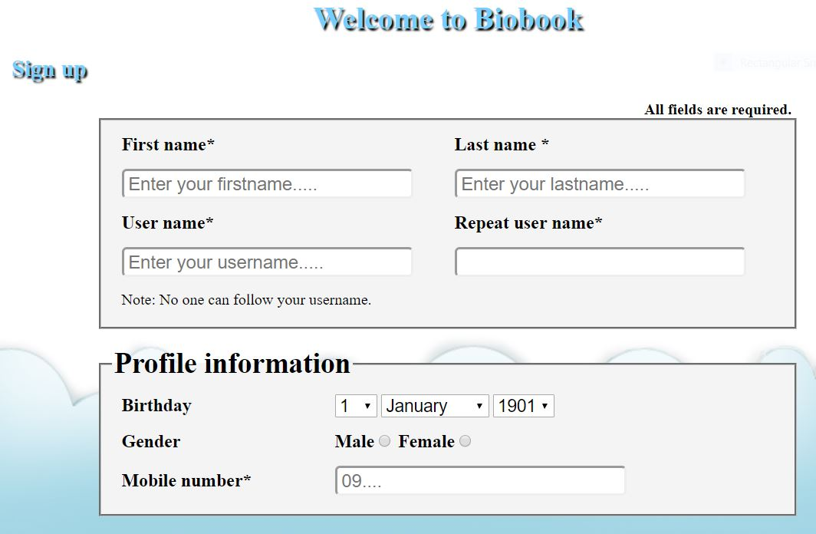
Fig. 4.2.1 Sign Up Form1

Fig. 4.2.2 Sign Up Form2


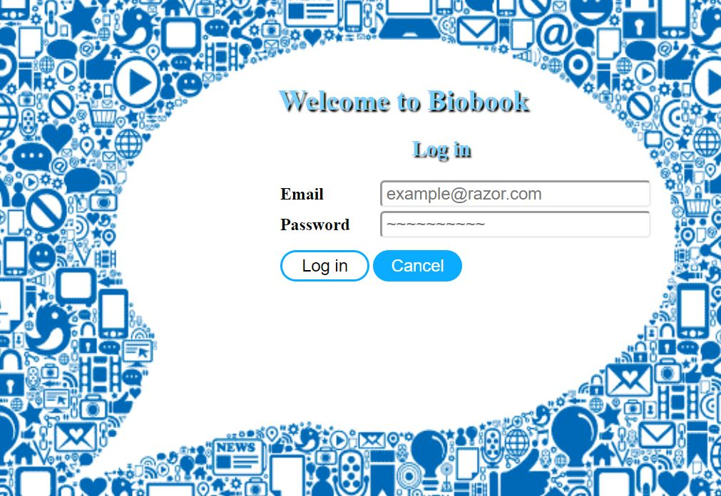

Fig. 4.3 Login Form

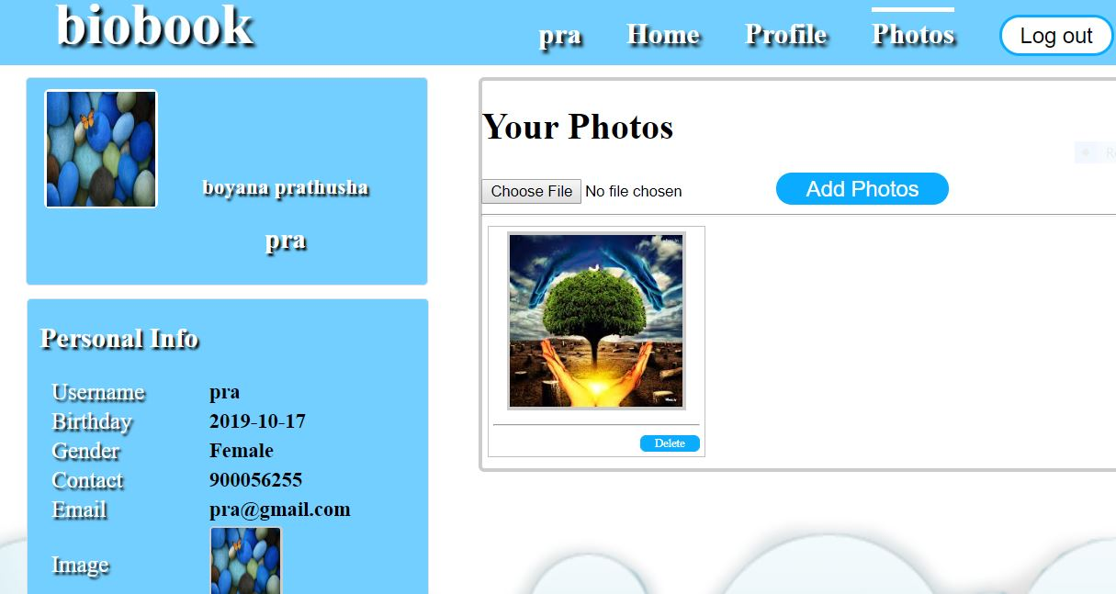
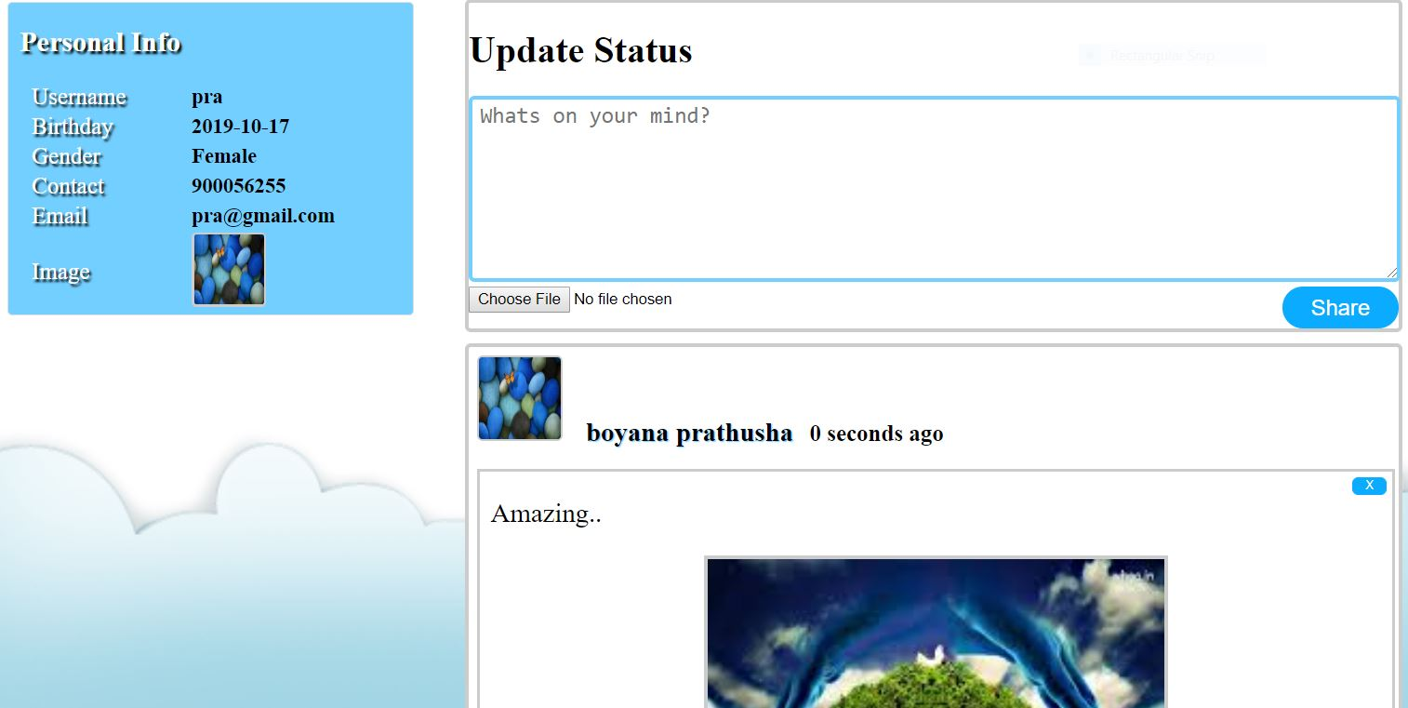
Fig. 4.4 Add Posts and Comments

Fig. 4.5 User Photos

Fig. 4.6 User Profile

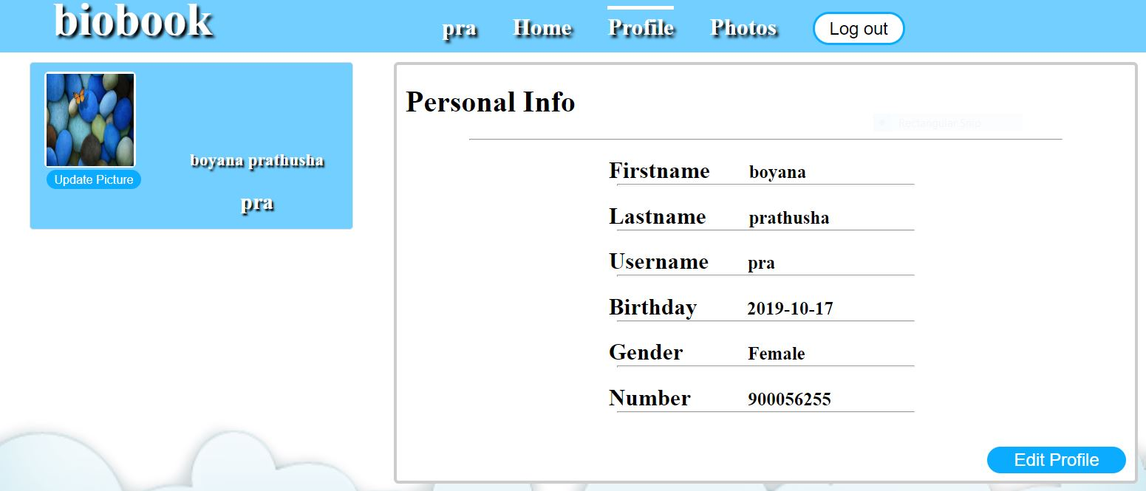

CONCLUSION

Final conclusion i.e., Social Networking website is a revolutionary idea with a very bright future with further scope for advancements. The opportunities provided from this medium are immense and many organisations are making use of this medium to better their practices.

REFERENCE TO PROJECT
1. Kogent Learning Solutions Inc, HTML 5 Black Book: CoverCSS3, JavaScript, XML, XHTML, AJAX, PHP and JQuery, Dreamtech Press, Second Edition, 2016.
2. W. Jason Gilmore, Beginning PHP and MySQL, APress, Fourt Edition, 2011.
3. Snig Bahumik, Bootstrap Essentials, PACKT Publishing, 2015 (e-book).

